*TER*

Automatic classification of Medical-students’ questions in accordance to the Taxonomy of Bloom

YACOUB Nabil

YACOUB Rémi

First week :

Pattern-looking inside each questions

Patterns : recurring sentence and regular-expression

level 1 patterns

At the beginning of questions:

*Parmi les affirmations suivantes concernant*

*Parmi les propositions suivantes concernant*

*Parmi *ces propositions concernant*

*Concernant*

*A propos de*

Amidst the middle of questions :

*les """",*

*la "",*

*le "",*

At the end of some questions:

*quelle(s) est (sont) la (les) proposition(s) exacte(s)?*

*laquelle/lesquelles est/sont exacte(s)?*

*laquelle(lesquels) est(sont) justes?*

*quelle(s) est(sont) le(s) affirmation(s) exacte(s)?*

*la(es)quelle(s) est(sont) vraie(s)?*

*quelle(s) est(sont) la ou les proposition(s) exacte(s)?*

level 2 (or level 3) patterns

Début des questions:

*un enfant de ""ans*

*un patient de ""ans*

*une patiente de ""ans*

At the end of a few questions:

*Parmi les propositions suivantes la(les)quelle(s) est(sont) exactes*

*Quel(s) diagnostic(s) évoquez-vous ?*

*Quelle(s) est(sont) la(les) proposition(s) exacte(s) ?*

*Quelle est votre attitude en urgence ?*

Heatmap with the *base* model (camembert-base)

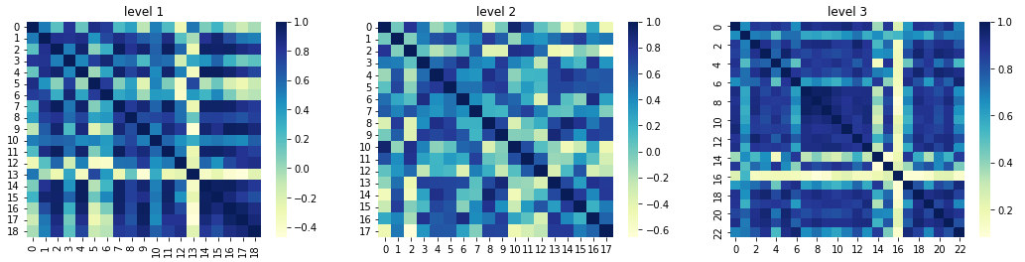

with the *base* model (camembert/camembert-base)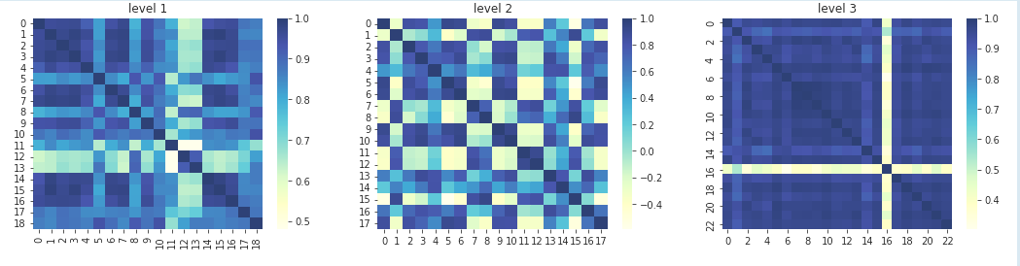

The matrix of the *base* model is better than than the *large* model in the level3:

(overall ; it depicts a better questions’ classification with each levels)

With this base model, we can observe a more homogeneous repartition of colors, which in turn makes it harder to decipher whether or not it is a better model (for some questions and not for other ones)

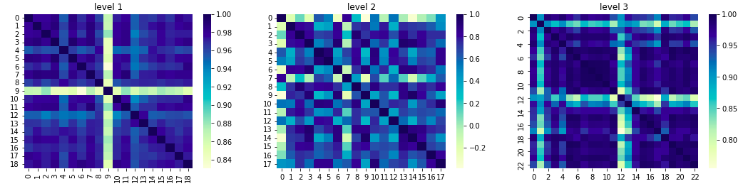

Heatmap with the *base-ccnet*  model (camembert/camembert-base-ccnet)

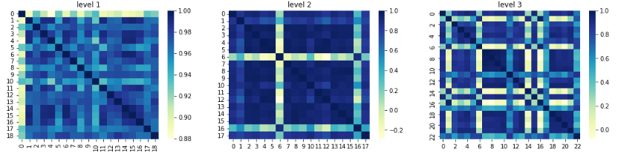

Heatmap with the *large* model (camembert/camembert-large)

Generally, we can follow the rule of searching for darker and more homogeneous results, nonetheless, this method also comes with some caveats (sometimes it’s a little harder to really distinguish)

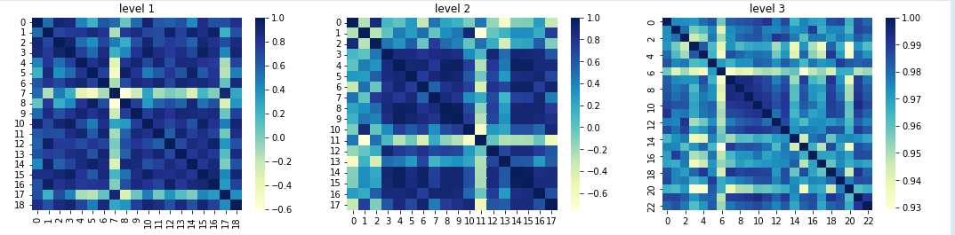

Heatmap with the *ccnet* model (camembert/camembert-base-ccnet-4gb)

For example, there are mainly *worse* results across all the *levels*,

However, that the homogeneousness of each results seen with *ccnet* are actually faring slightly better than in some previous areas (seen with other models)

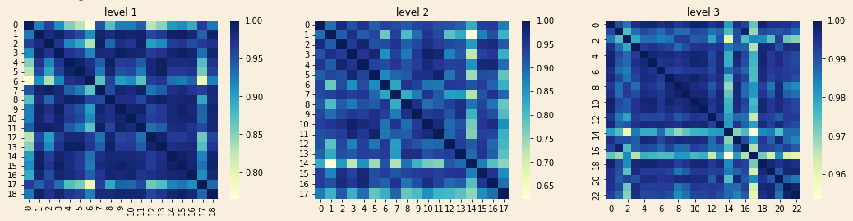

Heatmap with the *wikipedia* model (camembert/camembert-base-wikipedia-4gb)

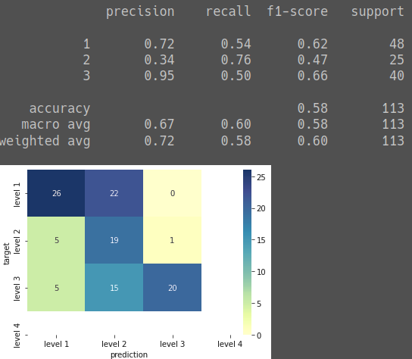

Camembert results

camembert-base

The model rendering the best Heatmap is the camembert/camembert-base-wikipedia-4gb. It shows improvement in both the SBERT sandbox and the CamemBERT sandbox (compared to the other models)

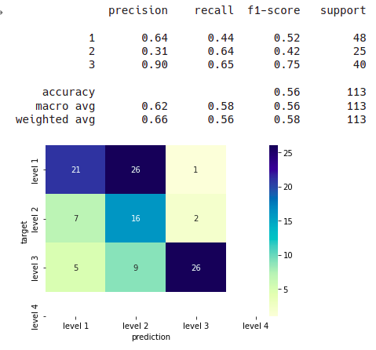

camembert/camembert-base-wikipedia-4gb

with the Camembert results

Lemmatizer

At first, we thought of using verbs for patterns 1 to 3

However, the main problem with using these verbs ; is that in the French language the conjugation of these verbs leads to a multitude of forms making their patterns rather difficult to detect, (being so diverse)

This is due to the fact that the French language has many irregular verbs and there are multiple exception rules. And so It can also be simplified, since we only use one language: French, so thankfully ; those sentences mostly use the present tense. Thus,it allows for the detection of verbs in sentences which require a simplified form of each verb : stemming

The questions are asked in the 3rd person singular, or in 2nd and 3rd person plural.

To solve this, we will use tools that allow us to recover the grammatical root(stems) of the verbs to ignore the conjunctive artefacts

List of common verbs in each levels

We classified with a manual approach (112 questions)

In the questions classified manually, we mainly focused on the questions (ignoring voluntarily the difference of context between the questions and the answers (meaning that presence of *numbers* in several answers are irrelevant)

Levels_1:

questions asked with a general present tense

*être, avoir,*

lesquelles, concernant, parmi, proposition

Levels_2:

A situational exercise with a patient categorised by age (infant, adolescent, adult...)

*voire, pouvoir,*

Levels_3:

Use of knowledge to apply to a specific problem: this requires numerical and binary values.

for example “présence de fièvre ou non”

*prescrire, réaliser, interpréter, durer, consulter, recevoir, amener, présenter, appeler,*

Conclusion of the first week :

We should mainly use the wikipedia-4gb model in the following weeks

Plans for the 2nd week :

* We could try influencing the verbs with the most frequent amount of apparition

in order to see whether they were actually that important

* We should choose more homogenous (darker when possible) results for every confusion’s matrix
* We should make comparisons with the removal of the numbers altogether
  + (that is to say: removing the numericals values of each sentence

“ 60 Litres “ => “Litres”,

* + or by replacing them and writing them in whole letters

“ 60 Litres “ => “ soixante/quelques/0 Litres” ,

* Plotting the ROC curve for another way of comparing results

Launch wikipedia-4gb w/ and with numericals values set at 0

Seeing the presence of *X RAYs*  within sentences, in each results for Lvls_2

|  |
| --- |
| Second week : |
| The matrices present varying results with the CamemBERT sandbox using the base-ccnet model, which can improve or deteriorate its results (in varying degrees)  ____________________________________________________________________ |
| Matrix of the CamemBERT sandbox  (model pretrained from camembert/camembert-base-oscar-4gb) |
| Matrix of the CamemBERT sandbox  (model pretrained from camembert/camembert-base-ccnet-4gb)  Some models (such as this one) seem too unbalanced, for our purposes |
|  |
|  |
| Matrix of sBERT sandbox intact numbers  (model pretrained from camembert/camembert-base-wikipedia-4gb)  There is a clear improvement on all levels of the results (perhaps with the exception of the level3),  which may due to the amount of digits it calls upon.  This might enhance the split with the other levels, but it can also degrade other parts of the classification in this aspect    Matrix of replaced digits with0 sBERT sandbox  (model pretrained on the same wikipedia-4gb) |
|  |
| Matrix of replaced digits with quelques sBERT sandbox  (model pretrained on the same wikipedia-4gb)    Matrix of replaced_digits_with_les/des sBERT sandbox  (model pretrained on the same wikipedia-4gb)  The swap of digits with more varied words (and less thus less recurring in their apparition) shows some improvements)  The results above may appear surprising, compared to the replacement of digits with *quelques* ;  As shown above, we obtained far better results by replacing them instead with *les* for the labeled parts and *des* for the unlabeled data, in order to reduce repetitions.    Matrix of deleting_digits sBERT sandbox  (model pretrained on the same wikipedia-4gb)  Overall, removing the digits altogether does not improve the models    Heatmap with the *ccnet-4gb* model  (camembert/camembert-base-ccnet-4gb)    Replaced digits with0 matrix with the *ccnet-4gb* model  (camembert/camembert-base-ccnet-4gb)    Heatmap with the base model (camembert-base)    Replaced digits with0 matrix with the basemodel (camembert-base)  This change yields a noticeable difference, on the *level1*    Replaced digits with quelques matrix with the basemodel (camembert-base)  Where as the complete removal of numbers globally yields worse results    Heatmap with the base-*ccnet* model (camembert/camembert-base-ccnet)    Replaced digits with0 matrix with the base-*ccnet* model (camembert/camembert-base-ccnet)    Heatmap with the *base-oscar-4gb model* (camembert/camembert-base-oscar-4gb)    Heatmap with the *large model* (camembert/camembert-large)    Replaced digits with0 matrix with the *large model* (camembert/camembert-large)  This decision seems to have enhanced the classifications on some parts, but most noticeably on the *level3* |
|  |
| (some sentences) replaced_with0 wikipedia_4gb for CamemBert |
| Conclusion of the second week :  We should avoid drastically reducing the amount of information (such as deleting all digits).  However, the wikipedia-4gb model fare less worse in some results :   * when selectively simplifying those digits with varied keywords, * or by giving them constants instead of digits (0) |
|  |
|  |
| Remarks :  Counting in all the levels' csv ( inside 6 files for each):  *find . -type f -iname "*.csv" -print0 | xargs -0 grep "radiographie" | wc -l*  We obtain that :  there are 2433 mentions of the word "radiographie" for *levels3* |
| there are 522 mentions of the word "radiographie" for *levels2*  This is not enough to draw a definite conclusion, but it seems more likely that the level3 is filled with most of *radiographies* descriptions.  However, whether it actually comes from the questions or from the answers ; that will require further reasonings.  We added a newly classified predictions called IQ_rbt_all_combined.with_predictions_students_revised.csv taking in consideration those remarks |
| Plans for 3rd week :  *detect incomplete sentences and reconstruct their answers*  *or*   * *rebuild every possibles answers (but it would multiply the numbers of questions by four, for each proposition)* |
|  |
|  |
|  |
| 3rd week    cardiovascular_questions.tsv  Even after erasing the “stopwords” from the dataset, we can still see many duplicates. This is due to the fact that most questions are considering all their possible forms of expressions, whether it’s singular or plural. |
| This reinforces our thoughts in rebuilding entirely the sentences, since we will need to filter out all those plausible use-cases of plural or singular questions, so that we can choose only the right answers. |
| Area under the ROC Curve  AUC    ***Level1*** ROC curve CamemBERT sandbox  pretrained on the *wikipedia-4gb* mode  Some failed attempts ….l |
| ***Level2***  ***Level 3*** |
| 4th week  Similarity between each level’s question’s embeddings    replaced_digits_with_plusieurs wikipedia-4gb_SBERT sandbox  The similarity between each level’s question’s embeddings below illustrates more promising results in the level 2 and the level 3, because they have higher values in the x-axis, most noticeably in the level3 which starts at 0.6 (for *plusieurs*) , instead of 0.2 (for *les*)    replaced_digits_with_des wikipedia-4gb_SBERT sandbox  similarity between each level’s question’s embeddings    Occurrences of the most common adverbs used to make questions in French: Que( quelles,quel,quels, quels),  comment comme(comment,comme), quand, pourquoi  For the adverb "que", its number of occurrences is almost the same for each level, but we have about 30% more in level 3.  For the adverb "comment", we observe occurrences in the three levels, but it is approximately 5 times more present in level 2 and 15 times more for level 3. Level 3 has almost three times as many occurrences as level 2.  For the adverb "comment", we observe occurrences in the three levels, but it is about 4 times more present in levels 2 and 3.  For the adverb "pourquoi", it is observed that it is present in the same quantity in level 2 and 3 and almost absent in level 1.  Occurrences of the most represented medical fields: radio (radiography, radiology, radiography...), imaging, neuro( neurology, neurography...), rhum, pedia(pediatrics..), allerg(allergology...), ophtal(ophthalo...),medecin,medicine  *Radio* and imagerie are mainly present at level 3.  *Allerg* is mainly present at level 1.  *Ophtal*,, *rhum* , *pedia* are mostly present in level 2 and 3 but in general slightly more in level 3  *Neuro* and *medicin* l are more in level 2 although present in level 3.  So we can say that depending on the field, we can have different levels.  Although level_2 does not have that many scientific units, because it compensates by putting us in the role of a doctor in a typical context.  For the last columns, we considered all the levels regrouped together. Nevertheless, it should be be separated with their actual levels in future comparisons, if we want to achieve a more thorough comparison.  ROC curves  **Level 1** plot with the *wikipedia-4gb* pretrained model with the CamemBERT sandbox  The AUROC values is almost the same for all of the levels, making it rather difficult to draw any conclusions; so let’s look at the ROC instead:  The ROC curve for **level 1** is always above the random prediction (dotted lines), which means that it presents good measures for its predictive accuracy.  The ROC curve for **level 3** is also mainly above the random prediction (dotted lines), meaning that it has good accuracy for its predictions.  **Level 2** plot with the *wikipedia-4gb* pretrained model with the CamemBERT sandbox  Unfortunately, the ROC curve for **level 2** is showing some values below the random prediction (dotted lines), even though it is only for a few of its values, it will demonstrate bad measures for its predictions. Therefore, we should consider this level2 as the one possessing the most margins of improvement in future runs.  **Level 3** plot with the *wikipedia-4gb* pretrained model with the CamemBERT sandbox  The false and true positive rates of each level show wide variations individually, however when we look closely level by level, we see that the values of the level1 have low rates, while the level3 have higher rates..  Finally the level 2 rates are distributed in between the level1 and level3    True and False Positive rates for each level  with the *wikipedia-4gb* pretrained model with the CamemBERT sandbox  Similarity between each level’s question’s embeddings    SBERT pretrained on *large*  Large has a level 1 that starts at 0.88, to -0.2 for level 2 and 0.0 for level 3.    SBERT pretrained on *base_ccnet*  The *base-ccnet* doesn’t fare well neither in *level 2*, nor in *level 3.*    SBERT pretrained on *wikipedia_4gb*  Overall, *Wikipedia_4gb* seems the best so far, because it has a level 1 that starts at 0.80, to 0.65 for level 2 and 0.96 for level 3.  *Large* is slightly more efficient for level 1 than *wikipedia_4gb*, but its levels 2 and 3 are worse than *wikipedia_4gb*.  So the *Wikipedia_4gb* will be used as reference for the comparison with the other figures.    SBERT pretrained on *ccnet_4gb*  Ccnet_4gb has a level 1 starting at -60, at -0.75 for level 2 and 0.93 for level 3.  Wikipedia_4gb is more efficient for level 1, 2 and 3, significantly for level 1 and 2.  So we will keep as a reference : Wikipedia_4gb    SBERT pretrained on *base-oscar-4gb model* (camembert/camembert-base-oscar-4gb)    Similarity between each level’s question’s embeddings  With the entire_phrase *pretrained* wikipedia-4gb_SBERT sandbox    Other runs of this very same model seen above can also give worse results for the levels 2 similarity  As seen here :  entire_phrase wikipedia-4gb_SBERT sandbox with questions and answers    The cosine similarity score are especially good in this model with the level 3    entire_phrase wikipedia-4gb_SBERT sandbox and removing artifacts and duplicates |
| Same run as the above : entire_phrase wikipedia-4gb_SBERT sandbox ; This one highlights how particularly unbalanced their similarities are compared to other levels (especially for the *level3*)      CamemBERT pretrained on *base-oscar-4gb model* (camembert/camembert-base-oscar-4gb)  We define a ROC curve (receiver operating characteristic curve) as a graph showing the performance of a classification model at all classification thresholds. This curve plots two parameters: True Positive Rate and False Positive Rate.  True Positive Rate (TPR) is a synonym for recall and is therefore defined as follows:    False Positive Rate (FPR) is defined as follows:    An ROC curve plots TPR vs. FPR at different classification thresholds. Lowering the classification threshold classifies more items as positive, thus increasing both False Positives and True Positives. The following figure shows the ROC curve of our model for each level of Bloom’s taxonomy.  *base-oscar-4gb CamemBERT*  **level 1 ROC**  We observe that the roc curve is always above the threshold, so we conclude that the level 1 is well classified.  *base-oscar-4gb CamemBERT*  **level 2 ROC**  **A**s mentioned previously, the level 2 shows rates going under the random prediction (dotted lines).  This highlights again the importance of this level 2 since it is the most unstable across all levels.  *base-oscar-4gb CamemBERT*  **level 3 ROC**  The level 3 shows rates going above and never under the random prediction. So the level 3 is well classified compare to level 2.  Large is the best pretrained in level 1.  Wikipedia4GB is the best for level 2.  For level 3, oscar_4g and Wikipedia4GB are the best.  5th week  Trees syntactic relations |

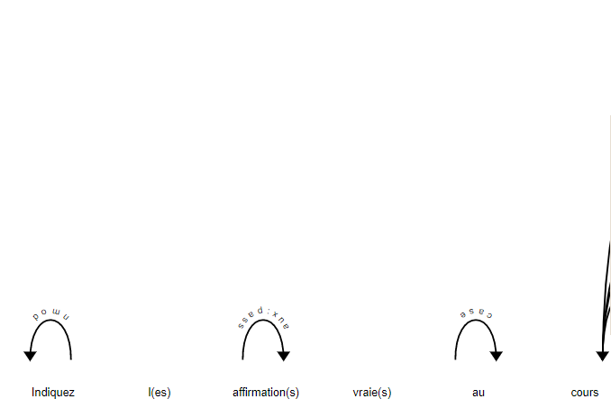

As we can see in this example,

**Some indications are less linked than their own propositions,** considering this fact, we shouldn’t ignore the answers : as they can bring about enriching links , especially for syntactic informations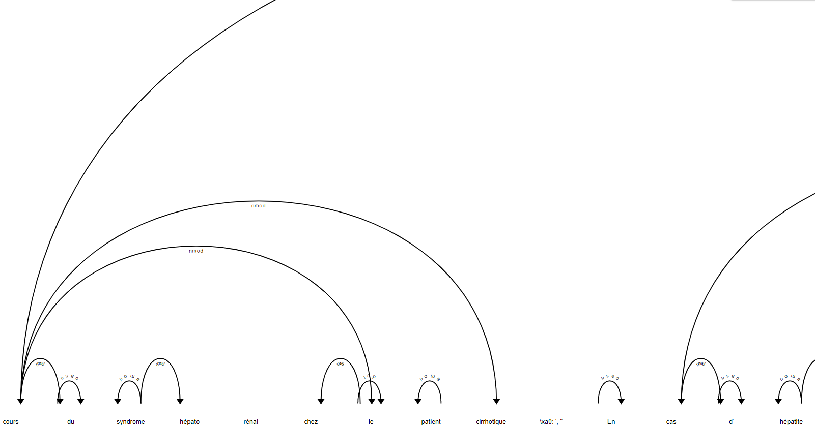

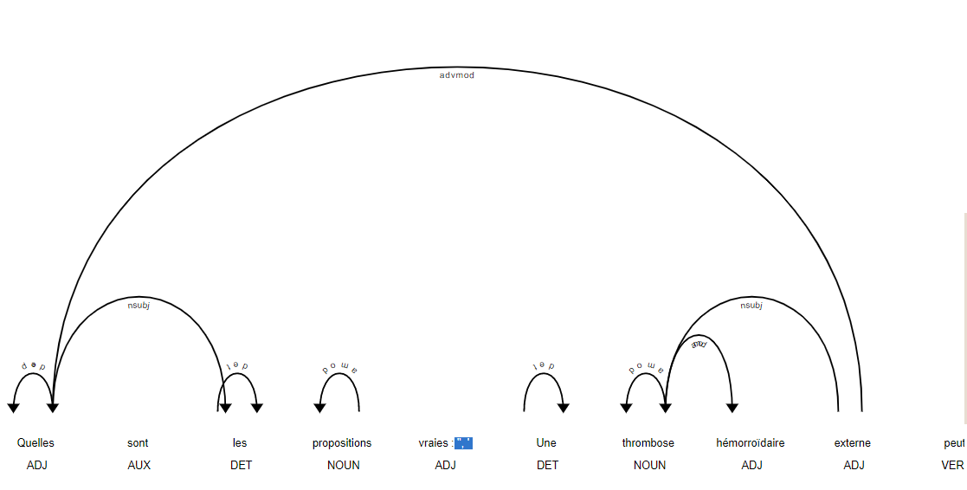

Moreover, we should avoid artifacts such as “stopwords”, unnecessary punctuations, or plurals ( as their parenthesis can be considered like additional punctuations ) ,

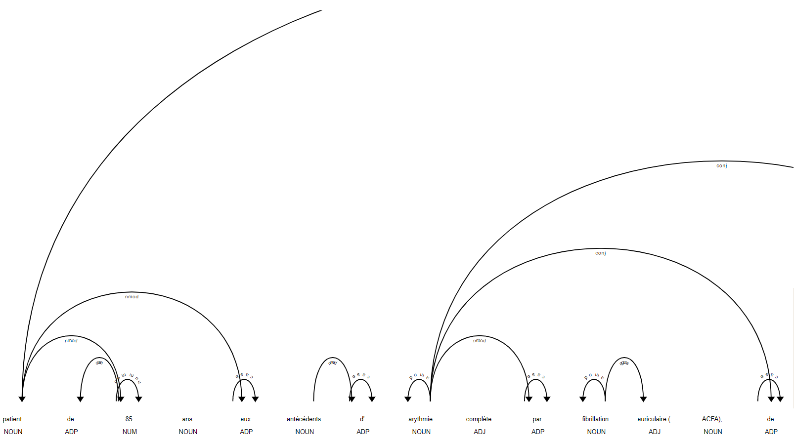

Numbers should be considered critical information, because they add fruitful links; like for example, in the above sentence.

Hence, erasing them could potentially result in a loss of those links

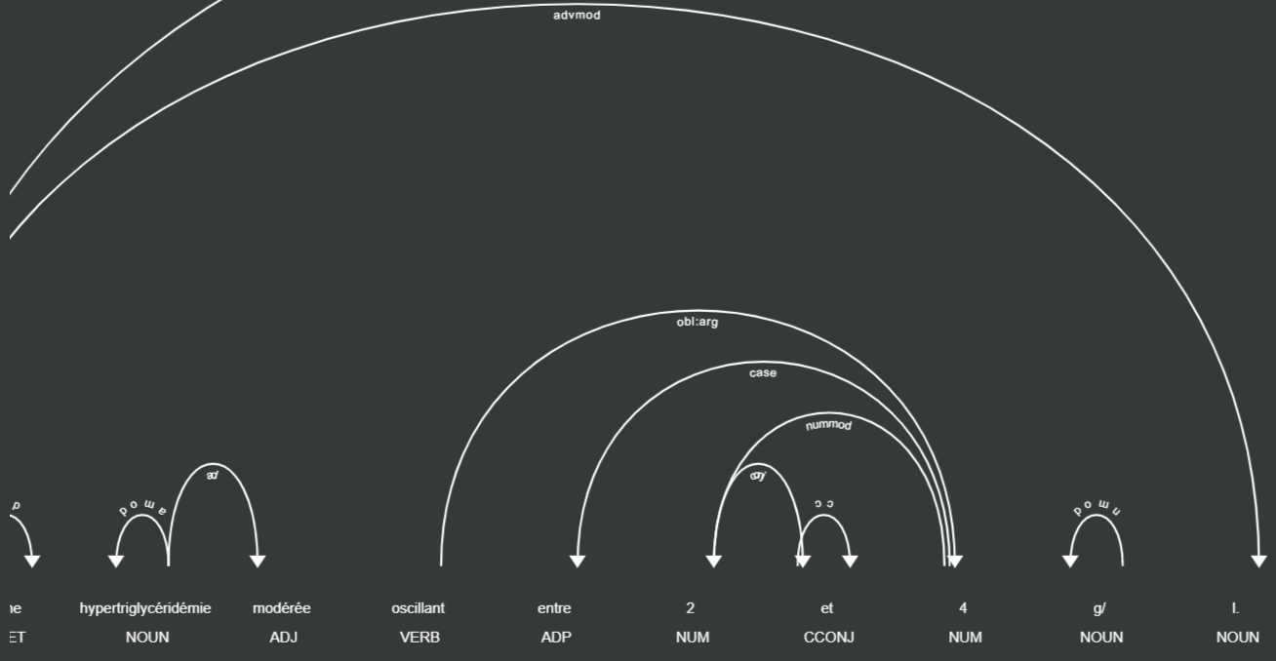

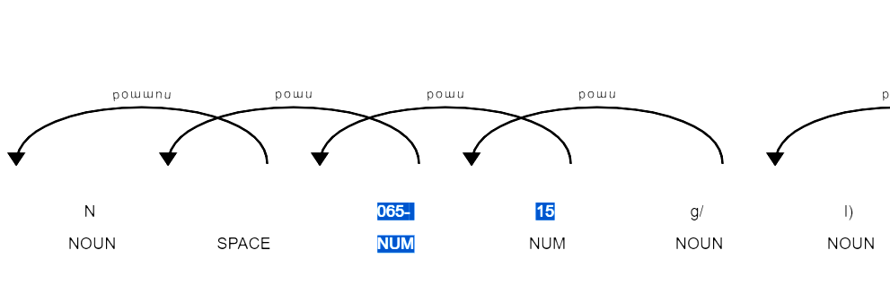

Furthermore, the replacement of digits can be tricky, since it would repeat for any phrase that enumerates them. This would require a thorough investigation of all the possible unexpected forms of expression, involving those lists of enumerations.

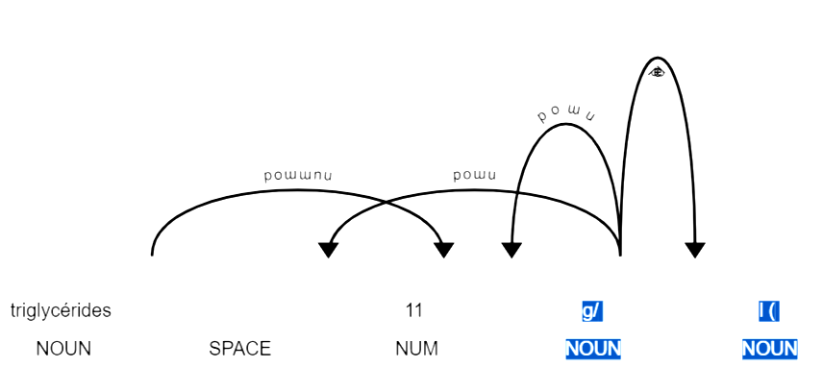

Meanwhile, it should be considered that : replacing all the acronyms could also help, especially if we want to make them more easily readable

For example, replacing all the */* with *by* instead could help create more clever additional syntactic trees

**We compare many models for our project.**

We compare models for our project. Wikipedia4g is the best in level 3 and 2. But, *large* is better in level 1.

So *Wikipedia4G* is better for questions around understanding and applying. And *large* is better for remembering questions.

However, the overall level-average criteria is well better for Wikipedia4G.

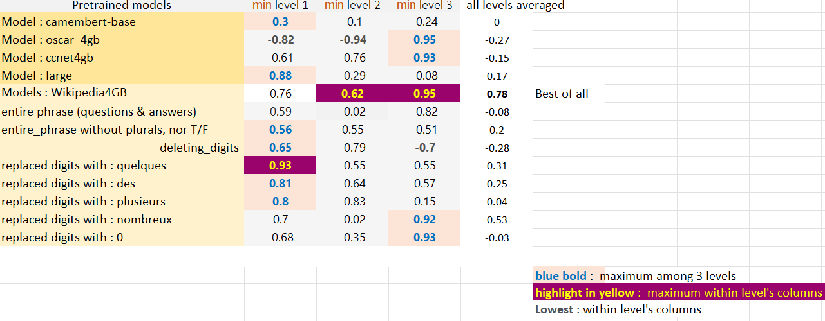

Wikipedia4gb model is used for those highlights

**All the *minimum* cosine similarity within each questions’ levels**

*Entire phrase stands for sticking the answers to the questions*

*The plural forms* la**(les)** *and the T/F* **(True)/(False)***, were erased in order to see if those made any difference when deleting all parentheses.*

All levels averaged of **wikipedia4GB**  is the best.

**Firstly, we compare the levels with each change made to the sentence : when we compare the sentence, when we combine the question and answers : we realize that it is showing worse results than with the questions alone.**

**We focused on the numerical values, which are mainly present in level 2 and 3 ’s**

**We replaced those digits by fixed words, to do so, we made several runs with different words**

**(by replacing decreasingly less commonly used equivalents), or 0, or simply deleting them.\***

**However, we came to the conclusion that even with a rarely occurring word such as “nombreux.se”, we still can’t come close to our golden standard**

**(intact wikipedia4gb) on level 2, (the other levels seem to fare better). Thus, we think that keeping this model is the wiser approach (so far..)**

*Large* is the best pretrainedt in level 1.

Wikipedia4G is the best for level 2.

For level 3, *oscar_4g* and *wikipedia4GB*  are the best.

Wikipedia4gb model is used for those highlights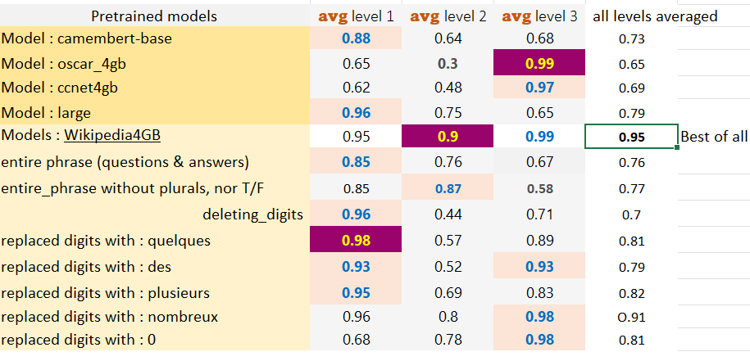

**All the avg cosine similarity within each questions’ levels**

**We observe the same remarks, with the exception of the *entire_phrase* model, meaning we shouldn’t only focus only on the minimums when trying to translate the predictions produced. Since their cosine similarity values can actually be pretty low (for their minimum), while keeping a good average values in the end.**

**So, adding more substance to the sentence’s shows good results for level 2, but it comes at the detriment of level *3*, which is an undesired outcome that has yet to be fixed.**

**Even if sometimes, we achieve better performance in level 1, it is at the cost of worsening level 2 and 3.**

**This is due to the fact that some replacements drastically change each sentence’s meaning, which is why a more case-by-case factoring of those newly generated artifacts is required.**

**We observe that the Wikipedia4GB is the best regarding *level 2* and  *level 3*, and the second best for *level 1*.**

**Then, we iterate over many ideas using it by default, to see how we can improve this model.**

**We observe that all of them have worst performance than the one we have with our original golden standard : *questions-only* Wikipedia4GB**

**Plan détaillé du rapport / plan d'avancement pendant la période à plein temps - 17/12/2021 à 23h59**

**\* Le plan des chapitres prévu pour le rapport ;**

**Abstract**

**Introduction**

**State of Art**

**Methods**

**-Reconnaissance des patterns propres aux nieaux 1, 2 et 3 de la taxonomie de Bloom dans les questions du dataset**

**-Etude comparative du modèle pour reconnaître ces niveaux et choix du meilleur**

**-Etude comparative sur l’étude des questions et des réponses**

**-Etude des valeurs numériques présents dans les niveaux et replacement de ces derniers par des motifs uniques**

**-Etude des termes ayant le plus de poids dans les questions pour déterminer leur niveau dans la taxonomie de Bloom**

**Results**

**Conclusion**

**Discussion**

**\* Pour chaque chapitre, indiquez l'état d'avancement. Donnez tous les détails dont vous disposez ; Si le chapitre est finalisé, indiquez-le ; autrement indiquez simplement ce qu'il reste à faire avec des liste (ex. « bullets points »);**

**-Reconnaissance des patterns propres aux niveaux 1, 2 et 3 de la taxonomie de Bloom dans les questions du dataset -Fini**

**-Etude comparative du modèle pour reconnaître ces niveaux et choix du meilleur -Fini**

**-Etude comparative sur l’étude des questions et des réponses -Fini**

**-Etude des valeurs numériques présents dans les niveaux et replacement de ces derniers par des motifs uniques -Fini**

**-Etude des termes ayant le plus de poids dans les questions pour déterminer leur niveau dans la taxonomie de Bloom -Non Fini**

**\* Donnez la liste exhaustive de la bibliographie que vous avez étudiée ;**

**Mains articles using during our project:**

**CamemBERT: a Tasty French Language Model,Martin & al,Proceedings of the 58th Annual Meeting of the Association for Computational Linguistics,2020,Journal Article,**

[**http://arxiv.org/abs/1911.03894**](http://arxiv.org/abs/1911.03894)

**OntoSIDES: Ontology-based student progress monitoring on the national evaluation system of French Medical Schools,Palombi & al,Artificial Intelligence in Medicine,2019,Journal Article**

[**https://linkinghub.elsevier.com/retrieve/pii/S0933365718301295**](https://linkinghub.elsevier.com/retrieve/pii/S0933365718301295)

**Sentence-BERT: Sentence Embeddings using Siamese BERT-Network, Reimers & al,2019,Journal Article**

[**http://arxiv.org/abs/1908.10084**](http://arxiv.org/abs/1908.10084)

**SentencePiece: A simple and language independent subword tokenizer and detokenizer for Neural Text Processing,Kudo & al,2018,Journal Article**

[**http://arxiv.org/abs/1808.06226**](http://arxiv.org/abs/1808.06226)

**Secondary Articles usable in State of Art:**

**RoBERTa: A Robustly Optimized BERT Pretraining Approach,Liu & al,2019,Journal Article**

[**http://arxiv.org/abs/1907.11692**](http://arxiv.org/abs/1907.11692)

**BERT: Pre-training of Deep Bidirectional Transformers for Language Understanding,Devlin & al,2019,Journal Article**

[**http://arxiv.org/abs/1810.04805**](http://arxiv.org/abs/1810.04805)

**Stanza: A Python Natural Language Processing Toolkit for Many Human Languages, Qi & al,2020,Journal Article**

[**http://arxiv.org/abs/2003.07082**](http://arxiv.org/abs/2003.07082)

**BART: Denoising Sequence-to-Sequence Pre-training for Natural Language Generation, Translation, and Comprehension,Lewis & al,2019, Journal Article**

[**http://arxiv.org/abs/1910.13461**](http://arxiv.org/abs/1910.13461)

**BERTRAM: Improved Word Embeddings Have Big Impact on Contextualized Model Performance,Schick & al,2020, Journal Article**

[**http://arxiv.org/abs/1910.07181**](http://arxiv.org/abs/1910.07181)

**Cross-lingual Language Model Pretraining,Lample & al,2019,Journal Article**

[**http://arxiv.org/abs/1901.07291**](http://arxiv.org/abs/1901.07291)

**Dual-View Distilled BERT for Sentence Embedding,Cheng & al,2021,Journal Article**

[**http://arxiv.org/abs/2104.08675**](http://arxiv.org/abs/2104.08675)

**SBERT-WK: A Sentence Embedding Method by Dissecting BERT-based Word Models,Wang & al,2020,Journal Article**

[**http://arxiv.org/abs/2002.06652**](http://arxiv.org/abs/2002.06652)

**UZH at SemEval-2020 Task 3: Combining BERT with WordNet Sense Embeddings to Predict Graded Word Similarity Changes,Proceedings of the Fourteenth Workshop on Semantic Evaluation,International Committee for Computational Linguistics,2020,Conference Paper**

[**https://aclanthology.org/2020.semeval-1.19**](https://aclanthology.org/2020.semeval-1.19)

**Longformer: The Long-Document Transformer,2020,Journal Article**

[**http://arxiv.org/abs/2004.05150**](http://arxiv.org/abs/2004.05150)

**HuggingFace's Transformers: State-of-the-art Natural Language Processing, Wolf & al,2020,Journal Article**

[**http://arxiv.org/abs/1910.03771**](http://arxiv.org/abs/1910.03771)

**Automatic Classification of Questions into Bloom's Cognitive Levels using Support Vector Machines,Yahya & al,2011,Conference Paper**

[**https://www.researchgate.net/publication/259463287_Automatic_Classification_of_Questions_into_Bloom%27s_Cognitive_Levels_using_Support_Vector_Machines**](https://www.researchgate.net/publication/259463287_Automatic_Classification_of_Questions_into_Bloom%27s_Cognitive_Levels_using_Support_Vector_Machines)

**\* Indiquez tous les produits intermédiaires (ex. tableaux de synthèse, graphique, maquettes, démo, etc.), peu importe leur état de développement, et donnez un lien où les retrouver sur votre dépôt (ex. github). Le but est de vos aider à améliorer ces produits pour le rapport et la présentation.**

[**https://drive.google.com/drive/folders/1XeYAHn6I7i9AxT1QD78MMCjqCPzpwM5l?usp=sharing**](https://drive.google.com/drive/folders/1XeYAHn6I7i9AxT1QD78MMCjqCPzpwM5l?usp=sharing)